***Office 365:***

● **Purpose:** A suite of applications for productivity, collaboration, and communication.

**Key Features:** Microsoft Teams, Word, Excel, PowerPoint, Outlook, OneNote,

OneDrive, Defender, and others. [2, 3]

● **Integration with SAP:** Can be used to manage documents and communicate with SAP

users, enabling integration and collaboration with SAP data.

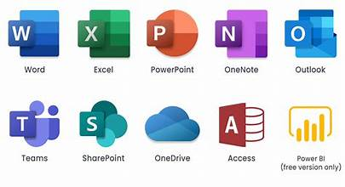

***SAP:***

● **Purpose:** An ERP system for managing core business processes. [2, 3]

● **Key Features:** Modules for finance, operations, human resources, sales, and marketing.

***Important Points:***

Office 365 is a tool for individual and team productivity, while SAP is a system for managing an organization's entire business.

They can be integrated to improve communication, collaboration, and data sharing, but their core functionalities remain distinct.

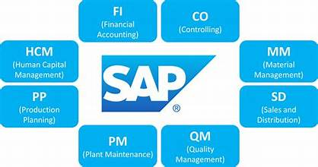

***Log files provide detailed information about the installation process, while Event Viewer helps identify system-level errors related to the installation.***

***Using Log Files:***

***1. Enable MSI Logging***: Specify the logging level (e.g., verbose logging) using the

command line parameters when running the MSI installer. This will create a log file in a

temporary directory, often C:\Users\<USERNAME>\AppData\Local\Temp.

***2. Locate and Review the Log File:*** The log file will be named something like "Msi.log"

and will contain detailed information about the installation process, including errors and warnings.

***Using Event Viewer:***

1. Open Event Viewer: Search for "Event Viewer" in the Windows Start Menu and open it.

2. Navigate to Windows Logs: Expand "Windows Logs" and explore "Application,"

"Security," and "System" logs, as these might contain relevant events.

3. Filter for Relevant Events: Use the "Filter Current Log" option to display only critical,

error, and warning events to narrow down the search.

4. Analyze the Events: Review the event details to identify the cause of the MSI

installation error. Look for event IDs, sources, and descriptions that indicate the specific

issue.

**Q 1.) Write the about Intune and write the Microsoft Intune deployment Steps:**

***Microsoft Intune****:*

Microsoft Intune is a **cloud-based Mobile Device Management (MDM)** and **Mobile Application Management (MAM)** service. It allows organizations to securely manage and control employees’ devices and apps—such as smartphones, tablets, and PCs—remotely from the cloud, ensuring data protection and compliance without needing on-premises infrastructure.

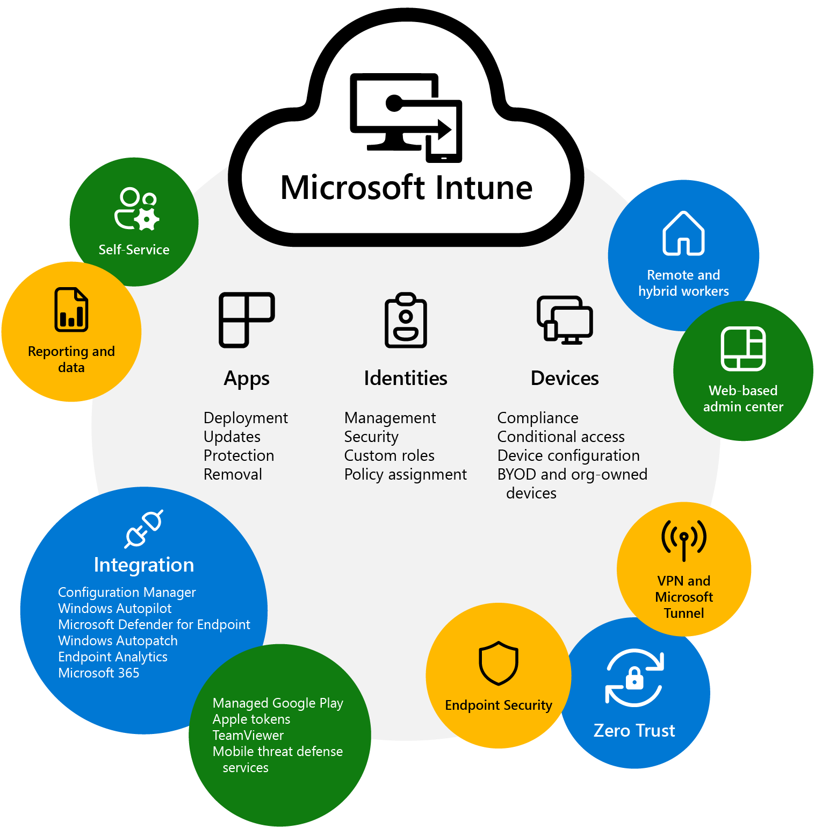

***Microsoft Intune deployment Steps:***

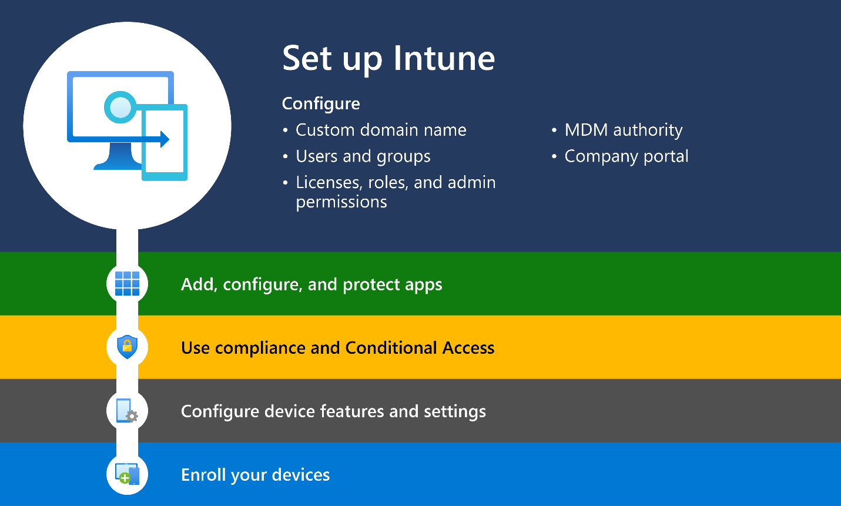

**1. Set Up Intune**

**- Sign in to the Intune admin center.**

**- Configure basic settings for your organization.**

**2. Add, Configure, and Protect Apps**

**- Upload applications to Intune.**

**- Set policies to control app behavior.**

**3. Use Compliance and Conditional Access**

**- Create rules to check if devices follow security requirements.**

**- Use conditional access to block or allow access based on compliance.**

**4. Configure Device Features and Settings**

**- Adjust settings like Wi-Fi, VPN, and security controls.**

**- Set rules for how devices should behave.**

**5. Enroll Your Devices**

**- Register devices with Intune for management.**

**- Ensure users follow enrollment steps correctly.**

**This process helps organizations manage devices, apps, and security in a structured.**

**Key Points:**

* **Silent install & uninstall commands** required.
* Max **package size**: 8 GB.
* Devices must run **Windows 10 1607+**.
* Devices must be **Intune-enrolled**.